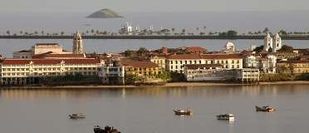
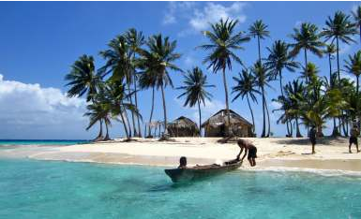
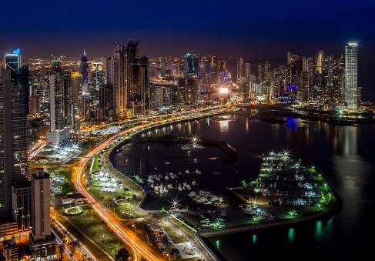
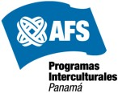

Country Guide for AFS participants hosted in Panama – High School Program

1
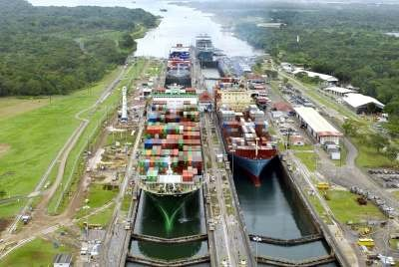

Hello !

We would like to give you a very warm welcome and congratulate you for having been selected for an AFS program with us in PANAMA. We are looking forward to meeting you in person and are eager to share with you our country and culture.

First, we would like to suggest that you clear away all the preconceived notions you have about Panama. You will come to find out that Panama is not just a Canal or bananas. Panama also has a rich and individual culture, many different communities with a diversity of identities and a large capital city with impressive architecture. Here you will find and adapt to many new different customs, behaviors and foods, among many other things.

This booklet is for foreign exchange students participating in an AFS Year or Semester program in Panamá. Read it very carefully before leaving your country and bring it with you !

We wanted to introduce you to our country in a simple manner and provide material that may be useful while you prepare for the trip, as well as to help you understand the rules and procedures of the AFS exchange program in Panama.

You may receive information through several other means, such as informal or unofficial comments by previous participants to Panama or other countries. Some of these comments may differ or even contradict what is mentioned in this booklet. This shows how unique and specific each AFS experience can be, and we recommend you to discuss any such information with the staff or volunteers at the arrival orientation, that you will attend.

Your host family will receive similar instructions, which will be used as a base to create a good relationship and help achieve the objectives of AFS.

Revised: February 2017.
1. THE COUNTRY

Panama links Central and South America and is a bridge between the Atlantic and the Pacific Oceans. Geographically, it is part of Central America, but culturally and historically it’s influenced by the Caribbean and South America. There is very limited cultural or historical connection with Mexico, so you should not expect to find spicy food, for example.

Based on the last Population Census done in the year 2010, Panama have close to 3.4 million people. Over 1.7 million live in Panama City and the surrounding urban areas, and the total national territory is 77,000 square kilometers. For you to have a better idea of the size, Panama is slightly larger than Tasmania, a bit smaller than Austria and the same size as North Carolina.

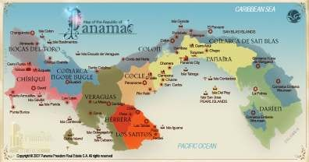

The political division is based on nine provinces and five indigenous territories. Each province has districts, and each district usually has a town or larger community of the same name. AFS programs operate in all provinces except in Darien. The indigenous territories have been created over the past several decades and allow for the environment and the traditional cultures to be maintained.

The climate is Tropical, which means very hot and humid, except in certain towns in the highlands of western Panama such as Volcán, Río Sereno, Cerro Punta and Boquete, which can be much cooler. For most of the country, the daily average temperature is of 25c or 75F. It can reach as high as 39c or 90F. The dry season, which we call “Verano” lasts from early December to mid April, and the rainy season is called “Invierno”, lasting from mid April to early December.

2. HISTORY

Over 60 original indigenous tribes that lived in Panama were reduced to 7 after the arrival of the Spaniards in 1501: Kunas, Ngöbe, Teribe, Bokotá, Bri Bri, Emberá and Wuonaan, which still exist today.

Panama became independent from Spain on November 28th, 1821 and voluntarily joined the Grand Colombia federation of South American States. After various tries, Panama became independent from Colombia on November 3rd. 1903,

Shortly after this independence, a treaty with United States granted privileges for the construction of the Panama Canal and the construction of the Canal had a huge influenced on the Panamanian culture with the influx of immigrants from all parts of the world.

Panama has totally and very successfully administered the Panama Canal since December 31st 1999. Right now there are projects taking place to expand the Canal, build a metro in Panama City and several others throughout the country which will influence the economy and promote Panama for at least another century.

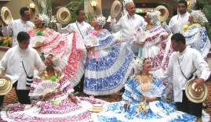
3. PANAMANIAN PEOPLE

Stereotypes and generalizations are not a good way to describe a whole nation, but we can share views that foreigners usually have of Panamanians:

Friendly and outgoing
Good dancers
Good humored, even in the worse situations
Takes life easily and without worries Always willing to help others Frustratingly unpunctual
Loud when talking or arguing
Concerned about other people’s opinion
Gossipy

You may find Panamanians who still think that:

Men are superior to women. A father’s word is final
Men don’t do house chores
Women should be gentle and take good care of their physical appearance: Do their nails, hair, makeup, etc.
The family always comes first, the individual second.

There is an evident influence of the United States in our society, particularly in restaurants and stores, music, in the people’s way of dressing, TV programs and movies, etc. Even Panama City, with its high rise buildings looks a lot like a US city...

One of the surprises that most foreign students get when they start their day to day life in Panama is when they realize that most Panamanian families do not have the cultural custom of having their meals together, all sitting at the table. It is common that family members eat in different places of the house, and at different times. But the most difficult situation may be that, most families, buy only the ingredients for a single meal each time. So, there is very little food or snacks to prepare or to eat between meals. For this reasons, it´s recommended that foreign students be home when the family meal is prepared and eats it as he or she sees do the other members of the family.
4. COURTESIES

Especially in the beginning, when you are likely to be introduced to a lot of people all the time, please remember that some common courtesies will help you cause a good first impression. You can then build on those first impressions the type of friendships and acquaintances that will make your stay in Panama a lot more fun.

When males are being introduced to any adult or a male close to your age, shake hands firmly and look at the other person’s eyes.

When males or females are being introduced to a female close to your age, kiss each other once on the cheek. Your mother is right ! It’s good to say Please: “Por favor” and Thank you “Muchas gracias”.
Entering or leaving a room without a greeting is rude in Panama too!. Be courteous to everyone, even small children or people you see often.

Always try to eat the snacks or cold drinks that may be offered to you at homes that you visit.

Keep your laundry in its proper place and separate from clean clothes. And NEVER leave wet towels or dirty clothes in the bathroom, over or under the bed, because our climate is too humid, it will make the clothes get bad odors.

Panamanian parents don’t allow that your friends visit you in your bedroom, especially if they are of the opposite sex.

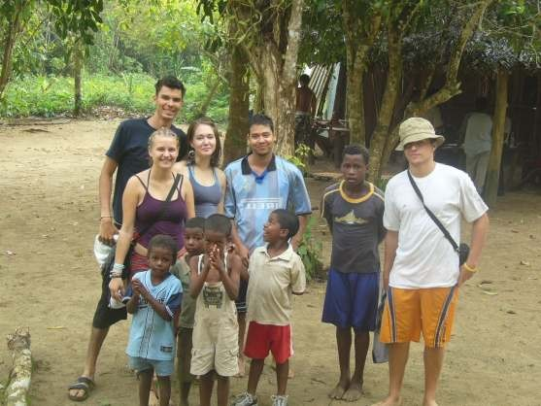
5. YOUNG PEOPLE

For Panamanian teenagers school homework comes
FIRST, then social life and entertainment.

Teenagers spend most of their time studying, watching TV, listening to music, meeting friends, etc. Parties, going out and social events are reserved for weekends.

Baseball, soccer and basketball are favorite sports. Sport facilities and youth organizations are not well established in most communities.

♥ Dating, as such, does not exist in Panama. Young couples who spend time alone with each other are considered
“novios”.

♥ The proper way to have a “novio” boyfriend, or a “novia” girlfriend involves that both set of parents approve of the relationship and its customary that the boy visit the girl at her house and take her out with her parents’ permission.

♥ Terms such as “special friend” or “just a friend” are not applicable and Panamanian people will still see couples that spend time together as “novios”. Parents usually don’t react well to having their children in a relationship that they are not aware of or disapprove.

♥ Dating somebody over 18 years old for a participant that is under 18 is against Panamanian law, and could end up in a confrontation with local authorities.

♥ Panamanian parents usually prohibit their daughters to have “novios” until they over 18 years old and are very much against close relations to boys or men who are from very different socioeconomic backgrounds, with an irresponsible lifestyle or much older. Even when foreign female AFS participants are obviously not looking for marriage, the same rules apply to them. Host parents might disapprove of dating or that you date someone they don’t like.

CLOTHES: Bring light, informal clothes such as jeans, cotton shirts and T-shirts, shorts, sneakers, one pair of black dress shoes, socks, cotton underwear, swimming suit, a towel. Students placed in Boquete, Rio Sereno, Volcán and Cerro Punta will also need sweaters, a light jacket and heavy socks due to the cooler climate.

It’s a good idea for female participants to bring at least a few simple cocktail dresses, to be used if invited to special occasions such as a wedding, christening or funeral. For male participants, a few short or long sleeve shirts are fine.

Things that you SHOULD NOT BRING:
- Clothes that need special cleaning procedures, such as dry cleaning.
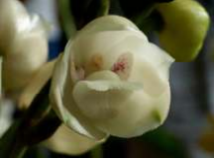
- Expensive or gold jewelry
- Items of great sentimental value for you
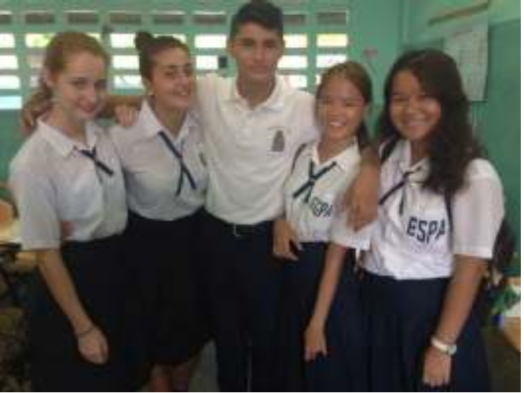
6. SCHOOLS:

Most AFS students participating in the Year or Semester Programs attend public schools. Some of students placed in
Panama City may attend private schools that waive tuition.

All these High Schools give transcripts of grades to exchange students who deserve them. This means that the student should consistently attend classes and take the tests and exams in all subjects. However, even if the grades are good, an official high school diploma can not be granted as the Ministry of Education requires that any student has at least two years in a Panamanian High School in order to get an official diploma.

Teachers commonly require some type of homework and friends usually study as groups that meet after school in their homes. These groups also go out to the movies, parties, etc. You may be invited to these groups, but only if you also take schoolwork seriously.

All students wear school uniforms. For public high schools where most of the AFS students are enrolled: Boys wear dark blue pants and white shirt. Girls use a dark blue skirt and white blouse. All wear black leather shoes and blue or white socks. For private schools, each school has its own type of specific uniform.

All foreign students must bring US$ 150.00 to buy school uniforms in Panama. This amount is enough to buy shoes, shirts, pants or skirts, socks and school emblems that are then sown on the shirts.

If you come in the “High School” program, you MUST attend a high school for the entire year. Changing to the University Program is not an option.

If you arrive to Panama in August or September, you will be enrolled in the Third Trimester of the 11th or 12th grade, there will be school vacations from mid- December until late February, and then attend the first and second Trimester of
11th or 12th Grade.

If you arrive in March, you can be enrolled in the first Trimester of either 11th or 12th grade. Some schools have classes in the morning or the afternoon. If given the choice, you should attend the morning sessions.

7. COMMUNICATION WITH FAMILY AND FRIENDS IN THE HOME COUNTRY

Of course, the most likely way you’ll use to communicate with family and friends will be the internet. Even if your host family has a computer and an internet connection, we encourage you to use an internet cafe. These are very common all over Panama, the usual cost is as low as US$ 0.50 or US$ 1.00 per hour. This way the family members can use their computer for their studies or own use, as foreign participants usually use them for too many hours and this usually creates conflicts with the host family.

If you use the host family’s computer PLEASE ASK FOR THE BEST TIME FOR YOU TO USE IT AND GET USED TO A LIMITED AMOUNT OF TIME (for example, no more than 1 hour each time). Also, don’t change the host family computer’s system, don’t download or install programs or music without their approval and never watch pornographic material.

Also, be aware that emails don’t give enough time to react calmly to normal emotional ups and downs involved in an intercultural experience, so give yourself the chance to think exactly what you want to communicate to your family before sending an email.

TELEPHONE

More and more Panama families no longer have a phone at home, as most family members have their own cell phones. Getting a cell phone in Panama is very cheap and easy and 70% of all Panamanians have one. AFS participants are encouraged to look for the best possible arrangement and the cost and types of services can be very different among the different cell phone companies. Don’t buy an expensive cell phone or sign up for high cost plan. For most students, the best deal could be prepaid cell phone cards, which are more expensive per minute but easier to control.

It’s best not to use the host family’s phone for international calls. It’s best to buy a PHONE CARD, which cost no more than US$10.00 and can be used either at home or a public phone. In case you make international phone calls from home, the cost will appear in the phone bill and you will be responsible to pay for it. These phone bills can run very high, so please avoid this situation. Collect calls can be made ONLY to the United States.

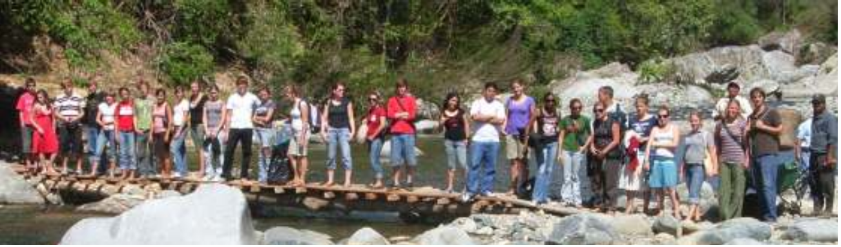
Be aware that phone calls between the AFS participants and their natural families and friends tend to interfere with the adaptation process. The ideal would to call no more than once a month. If you are having a difficult situation, even if you inform your natural family first, it will be the responsibility of the local volunteers and the National Office to help you identify a solution. We encourage you to talk directly to this support network in Panama
.
MAIL

Mail service in Panama is generally safe but letters to or from Europe and Asia take at least 2 weeks and to the US
about 7 days.

Sending or getting packages takes considerably more time (sometimes up to eight weeks from / to anywhere in the world) If you receive a package from home, you may have to pay TAXES, and please don’t have family and friends send personal packages to the AFS Panama office address. Have them send any package directly to you, the volunteers and AFS Office Staff can help you identify the best way to do this depending on where in the country you live.

Most AFS participants have a General Delivery mail address. This means you need to go to the local postal office to get your mail, by asking the clerk if there is any letter or package for you. It is very important that your family and friends in the home country send you letters to the correct address, which in most cases start with the words “Entrega General” that means general delivery and the name of your town, province and country.
A typical and correct general delivery address would look like this: “your name”
Entrega General
“host community”, “host province” PANAMA

Some host families have a post office box, and in that case, your name must be added by the host family so that the mail service accepts your letters and packages in that post office box.
A typical and correct post office address would look like this: “your name”
C/O “your host father or host mother´s name”
Apartado 9999-9999
“community where the post office is located”, “province”
PANAMA

Look in your Host Family Application to determine what type of mailing address you need to use while you live in that host family.

DO NOT SEND MAIL TO THE HOST FAMILY´S RESIDENTIAL ADDRESS, as it will take much longer or never arrive. The Panamanian mail system does not rely on distributing letters or packages to people´s own homes. The residential addresses are used only to know where people live, and AFS participants should be aware of the address but not for mailing purposes.

8. GIFTS FOR THE HOST FAMILY

You may probable want to bring a small gift to your host family. Previous students have suggested typical things from your country that are small, easy and safe to carry, such as books, candy, T-shirts, caps, Key-chains, etc.
9. KEEPING YOUR VALUABLES SAFE

AFS Panama is not responsible for any loss or theft of money or valuables suffered by the participants, and recommends the following:

Keep only small amounts of money in cash. Don’t carry large amounts of money (Over US$40) on you unless you are planning to spend it right away. Never leave any money in plain sight or anywhere that is not properly locked at your host family home, school or any other place

Never lend money to anyone: Friends, other foreign students, host family members, etc. If someone asks you for money, tell him or her that AFS does not allow you to lend money and inform a volunteer or the National Office Staff that you have been approached by someone asking for a loan.

Never put your money in bank accounts of friends or members of the host family! It is difficult for foreigners to open a bank account in Panama, but never accept any offer to have your money under someone else’s name or account.

Always carry your credit card with you. Never share your PIN (Personal Identification Number) with anyone, not even your closest friend.

Be careful where you leave your passport and visa card! Before leaving home, it’s a good idea to make a photocopy of the information page of your passport, and always carry a copy while in Panama. Once you arrive to the country, the AFS National Office may need your passport for several weeks to take it to the Immigration Office in order to get the visa extension. AFS Panama will give you an identification card for you to use while in the country. As soon as the visa is extended or in case of any emergency, the passport will be returned to you.

Upon arrival, all students are advised to discuss with AFS Panama National Office matters concerning their particular situation regarding money or safekeeping issues in order to avoid misunderstandings of the above mentioned items.

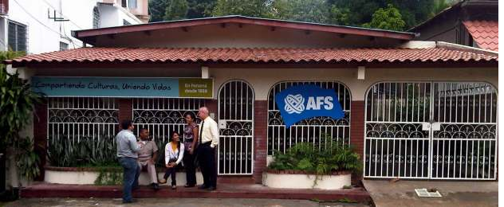
AFS Panama National Office in Panama City.
10. GETTING MONEY FROM HOME

By far, the best way to bring money from home is by getting a debit or a credit card before leaving. Make sure it allows for withdrawals of cash at any ATM (automated teller machine) in Panama, which your bank can confirm. The usual international cash withdrawal systems are called “Plus” and “Cirrus”. These names should be in the back of your card.

One of the best ways to get money from home quickly and cheaply may be through “Western Union”, the international money transfer service that operates all over the world. You can look for information about them in the internet at www.westernunion.com and find out how much is charged to send the amount of money you expect. If the host community in Panama is not listed as an agent location, there should be a larger city nearby where an agent operates.

Bank Transfers are good only after both the foreign participant and the natural family have discussed this option with their banks both in Panama and the home country. Make sure your parents put your name, complete address and phone number when they are giving information to the bank in your country. Also how will the money reach the bank in Panama, asking for specific banks participating in the transaction as it may involve several banks along the way. This system usually takes several days and may be considerably more expensive.

BANK ACCOUNTS

It’s very difficult for foreign nationals, especially minors, to open bank accounts in Panama. It depends on how flexible local bank officials decide to be with each foreign student. Host family members and local volunteers can be helpful in this matter, especially if they happen to know someone who works at a local bank but remember; Bank accounts should only be opened under the foreign student’s name. never open a joint account with anyone and never deposit your money in someone else’s account.

11. PASSPORT AND VISA

Most AFS participants arrive to Panama with a “Tourist visa” or do not any visa to enter the country. AFS Panama has a special agreement with the Immigration Department, so that these tourist visas are extended for the duration of the program. During the Arrival Orientation, within 48 hours after arriving to Panama, AFS participants go to Immigration offices to get registered. Several weeks later, all participants return to these offices in small groups to get the Temporary Residence Permit and ID cards.

At the Arrival Orientation site you will be asked to fill out the Immigration Office registration form, that the volunteers will help you complete. You will also need to bring the following, everything to be collected at the Arrival Orientation:

• A photocopy of ALL pages of your entire passport – Use 8.5 inches X 11 inches paper or use A4 size.

• To pay for the Temporary Residence Permit, each Year or Semester Program participant should pay US$350 in cash at the arrival orientation.

• 8 passport size pictures (1.5 inches X 1.5 inches) showing your full face, no glasses. Each picture MUST be individuallycut before giving them to AFS Panama. These photos must be printed on PAPER, not plastic. This is especially important for participants from Thailand, who many times bring pictures printed on plastic that can´t be used.
12. AFS PANAMA RULES

Some rules, defined both internationally and nationally, apply to all AFS participants and are designed, in all cases, to avoid situations that could jeopardize the participant’s safety and success in the program.

AFS International rules

1) No driving
All AFS participants are forbidden to drive any motorized vehicle, including cars, motorcycles, motorscooters, powered bicycles, airplanes, boats, helicopters, etc. This rule applies to driving in private land, driveways, parking lots, etc. as well as public roads. The participant is forbidden to drive in Panama , even if he or she has a valid driver’s license from the home country.

2) No drugs
Possession and use of illegal drugs is not allowed by AFS. Foreign participants are not immune to Panamanian laws and the penalties for dealing, carrying or using illegal substances are very severe. Any violator of this rule that is caught by Panamanian police will be fined and imprisoned no matter how small the amount and the natural parents are responsible for all legal fees and costs related to any drug offense.
AFS participants are strongly encouraged to avoid places, activities and people related to illegal substances in order to avoid any legal actions taken by the authorities against these, as well as to maintain a positive perception of the participant’s habits by the community.

3) No hitchhiking
Although it may be common and safe for you to hitchhike in your country, this can be quite dangerous in many countries, including Panama. It is very uncommon to find honest people asking strangers for a ride. For your own safety, you should refrain from the practice.

AFS Panama rules

1) School, University and Community Project attendance
All AFS participants must comply with the school, university or community project attendance requirements. This includes their rules regarding dress code, consistent attendance and acceptable behavior. In case a participant is expelled for any reason it could be a cause for an early return to the home country.
Any participant expelled by the school, university or work project will be returned to the home country. The usual reasons to be expelled are poor attendance, being in public areas of the school when the rest of the class is in session, inappropriate physical contact in public, not complying with the code of the school uniform, poor grades, etc.

2) Policies on drinking alcoholic beverages
Most host families in Panama expect their AFS participant not to drink alcohol and all will be greatly disappointed if the participant comes home drunk. Host families determine specific rules regarding drinking alcohol for individual AFS participants. In case that a host family complains to AFS about the drinking habits or any specific incident involving alcohol consumption, AFS Panama will consider it ground for disciplinary measures and a change of behavior will be expected. If participant insist, it could be a reason for a ER.
All AFS Panama activities, including orientations, social events and trips organized by volunteers or the National Office are completely alcohol free. Everyone taking part in these activities needs to confirm that there will be no alcohol involved.

3) Policies on travel

These rules apply to any travel that involves leaving the host community or overnight stays outside the host home.

3.1 Inside the country with members of the host family: If the AFS participant travels with any member of his or her immediate host family (parents, siblings), the school or the community service project, the AFS Local Representative should be given information regarding dates, itinerary and telephone number where they can be reached in case of emergency.

Outside the country with members of the host family: AFS participants in Panama can travel outside the country with host parents and host siblings after the participant has obtained the visa extension from the Immigration Office, which usually lasts no more than 3 months. Travelling outside the country before getting the visa extension will interfere with the process and is not allowed.
The participant will need a signed waiver called "Program Release” provided by the AFS Office in the SENDING
country and signed by the natural parents in the case of High School students regardless of age, and by the participant him or herself if in the Community Service or University Programs. This document releases AFS of any responsibility except reimbursement of medical expenses during the travel period and must be in the AFS Panama National Office before the participant leaves Panama and should include the dates and destination of the trip.

3.2 Inside the country without members of the host family:
Any trip inside the country without members of the immediate host family (this means parents, siblings or other family members living in the host home) involving at least one overnight stay is considered independent travel. These trips require completing the form “PERMISO PARA VIAJE INDEPENDIENTE” that host families need to sign, and should be presented for approval to the AFS Local Representative at least one week before the trip. The form requires that the participant inform the travel dates, destination, accommodation, names and age of travel companions and contact information in case of emergencies. It is understood that the participant covers all expenses related to independent travels.
Depending on the nature of the independent travel and the level of personal risk for the participant, as perceived by the Staff of the AFS Panama National Office, a “TRAVEL WAIVER” may be required. A Travel Waiver is a document provided by AFS.
Places in Panama that REQUIRE TRAVEL WAIVERS are: Trips to the islands in Bocas del Toro, Venao Beach, Santa Catalina Beach, trips to Kuna Yala, Coiba Island, Darien Province, climbing Barú Volcano, any trip that requires taking a boat or being near a cliff.
Depending on their Program, participants get a Travel Waiver by doing the following:
3.2.a. High School Programs (Year and Semester) Travel Waivers are provided by the AFS National Office in the Sending country and must be signed by the natural parents at least one week before the trip, as it needs to be faxed to the AFS Panama National Office before the trip begins. The Travel Waiver has to be requested to your Hosting Coordinator via your Local Volunteer. If you are unsure about whether you need a Travel Waiver or not, you should consult your Volunteer.

3.3. Outside the country without members of the host family:
Any trip outside the country is considered a temporary release from the AFS program. A document called “Program Release” needs to be signed. This means that AFS has no responsibility during the duration of the trip or while the participant remains outside the hosting country, except for reimbursement of medical expenses as described in the participation agreement during the dates mentioned in the Program Release.
These trips require completing a form that needs to be presented to the AFS Panama National Office, The form requires that the participant informs the travel dates, destination, accommodation, names and age of travel companions and contact information in case of emergencies. It is understood that the participant covers all expenses related to the trip.
Participants arriving in Panama in August, are encouraged to plan their trips outside the country in the month of January or February of the following year, which coincides with school vacations and the visa extension has been issued. Participants arriving in Panama in March are encouraged to plan their trips outside the country during the mid-term vacations, usually the last week in July and first week in August.
Participants can’t miss classes or work in their community service project for more than two weeks because of a trip outside the country.

Depending on their Program, participants get a Program Release by doing the following:

3.3.a. High School Programs (Year and Semester) Program Releases are provided by the AFS National Office in the Sending country and must be signed by the natural parents at least one week before the trip, as it needs to be faxed to the AFS Panama National Office before the trip begins. The participant is fully responsible for all costs and for obtaining the Exit Permit from the Immigration Office, which requires the payment of a fee of approx. US$50.00 and an in-person interview at the Immigration Offices in Panama City or the city of David. The AFS Office only provides a written guide about how to do this procedure.

5) Polices on visits by relatives or friends from the home country.
Visits by members of the natural family and friends from the home country can be very disruptive to the participant’s adaptation process and, regardless of the circumstances of the visit, they put undue burden on the participant, the host families and the local AFS volunteers.
AFS participants hosted in Panama are strongly encouraged to delay visits by relatives and friends until the last two months of the program and are ALWAYS required to inform the AFS Local Volunteers and the AFS Panama National Office, at least four weeks in advance, about their plans to have this type of visits.
Any relative or friend from the home country that is planning to visit a participant hosted in Panama must first contact the AFS National Office in the sending country to ask for approval for the visit. This approval will be made in cooperation with AFS Panama.
Any AFS participant that receives a visit by a relative or friend from the home country and is planning to travel with this person around the country, must present a “Program Release” see point 3.3.a. above. This Program Release must be in the AFS Panama National Office before the participant leaves the host family.
Because the participant is expected to attend school or the work project as a priority, travel around the country with friends or relatives from the home country should happen during school vacations or the vacation time allocated by the work project. The recommended times of the year to do this are: For participants arriving in August - During the months of January or February. For the participants arriving in March: Mid-term vacations, usually the last week in July and first week in August. AFS can cancel any travel or plan if it is planned in school time.

6) Policies regarding places of entertainment
All High School Program participants, regardless of their age at any time during their stay in Panama, are not allowed to attend places reserved for adults by the law. These include discos, bars, dance halls, casinos, etc. This rules has no relation to participants being over the age of 18 or not.
Host families and local volunteers are open to discuss the reasons why high school students should avoid these places.
Participants in the Community Service and University Programs, all of which are over the age of 18, are cautioned about the type of safety measures that anyone attending these places should exercise. These include avoiding talking drinks that have been handled by strangers, taking extremely good care of personal possessions such as handbags, wallets, cameras, etc.

13. AFS in Panama

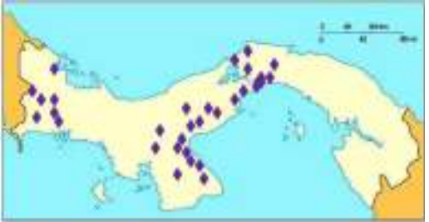
AFS operates in Panama since 1959. Most cities in the country have an AFS Local Chapter, and there are 32 chapters. Local volunteers are the ones that look for and select host families, organize local events and provide support to the participants.

Each chapter has an AFS Local Representative, a volunteer that coordinates the Local Chapter and may be the one that does most of the work. Other volunteers help as Counselors or Treasurer.

The AFS Local Chapters sometimes organize social or educational events for the AFS participants, any trip or fun activity they do is voluntary, there is no obligation or plan for them to coordinate tours to other places in the country.

Some volunteers coordinated directly by the AFS Panama National Office may offer to organize optional tours, paid by the participants, to places like Kuna Yala, Bocas del Toro, climbing of the Barú Volcano, etc.

The AFS Panama National Office is located in Panama City. Participants are always welcome to contact the Staff by calling the office phone 223-8477. If you want to visit the office, please call the Staff ahead of time, to confirm that the person you want to talk to will be in.

All participants can place an automatic collect call from any private or public phone by dialing 101. The automated system will require that you dial 2238477# and then say your name clearly after the tone. If there is anyone in the office, the call will get through and AFS pays for it.

Staff:

Plinio Benavides - National Director

Amado Morales - Hosting Coordinator School Programs

Nitzia Hazlewood - Hosting Coordinator 18+ Programs

Jeanette Salinas – Administrative Assistant

Isela González – Receptionist

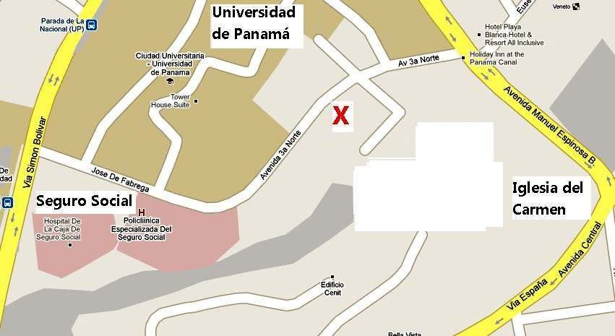
Location of the AFS Panama National Office in Panama City:

