Youth Exchange and Study (YES) Program
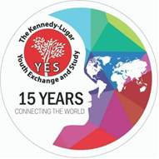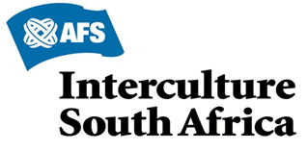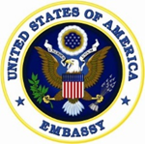
The Youth Exchange and Study (YES) is a program established in October 2002 and is sponsored by the Bureau of Educational and Cultural Affairs of the US Department of State to provide scholarships to high school students between 15 and 17 years old, from countries with significant Muslim population, who will have the opportunity to attend an academic year in the United States. This program is vital to expanding communication between the people of the United States and its partner countries, in the interest of promoting mutual understanding and respect. Students live with host families, attend high school and engage in activities that allow them to learn about the American society and values, acquire leadership skills, and help educate Americans about their country and culture.

From 2003 to the present, more than 10,500 students have participated in the KL YES program. During the academic year 2018-2019, more than 850 students joined the program, coming from: Afghanistan, South Africa, Bahrain, Bangladesh, Brunei, Egypt, Ethiopia, Gaza, Ghana, India, Indonesia, Iraq, Israel, Jordan , Kenya, Kuwait, Lebanon, Malaysia, Mali, Morocco, Nigeria, Oman, Pakistan, Philippines, Qatar, Saudi Arabia, Senegal, Tanzania, Thailand, Tunisia, Turkey, West bank of the Jordan River, Yemen and Mozambique.

In 2008, Mozambique was selected and sent five students to the US for the first time in the program, in the 2009-2010 academic year. Since then, more than 100 Mozambican students have participated in the program.

On their return, the students apply their leadership skills in their countries of origin. In addition, they form groups of former participants, called ALUMNI which are involved in many community service activities including collection of clothes for donation, counselling young people and children and English teaching, immunization campaigns and more.

The YES program is managed by four organizations and their partners in each country. In Mozambique, AFS-USA works with AFS Interculture South Africa, in collaboration with the YES Alumni Mozambique Association (AYAMO).

In addition to Mozambique, AFS implements the YES program in South Africa, Saudi Arabia, Egypt, the Philippines, Ghana, India, Indonesia, Malaysia, Kenya, Thailand and Turkey.
For more information on the YES/AFS programs, please consult www.afs.org.za. On this site, AFS answers the most common questions raised in the recent implementation of its programs.

REQUIREMENTS:

i. Be Mozambican currently living in Beira, Maputo, Nampula, Pemba;
ii. Be aged between 15-17 years old; Born between January 2003 – August 2005
iii. Be attending between 9th and 11th grade of the National Education System. iv. Have NOT failed in the last 3 years.

CONTACT INFORMATION

For general information about the YES program, contact YES@state.gov or
www.afs.org.za.
In Mozambique, please contact the Public Affairs Section of the US Embassy
MaputoExchangePrograms@state.gov; Arsénio Penga arsenio.penga@afs.org or 84 504 6089 (National Coordinator - Maputo) and Jonito Ribeiro jonito.ribeiro@afs.org or 82 358 2916 (National Coordinator - Nampula).

Below are other useful contacts and places for collecting information about the program:

• Instituto de Línguas de Nampula
– Dr. Saeze;
• Evanildo Bambamba (Maputo)
84 58 31 931;
• Malik Priyanca – 82 198 6162 (Maputo)
• Maximiano Mangue (Maputo) –
84 63 66 133;
• Merce Patrício (Nampula) – 84
387 2545;
• Nadine Rodriguês (Nampula) –
82 316 4329;
• Sunisa Casúla – 085 069 0995 (Nampula)

