AFS Code of Conduct for Volunteers
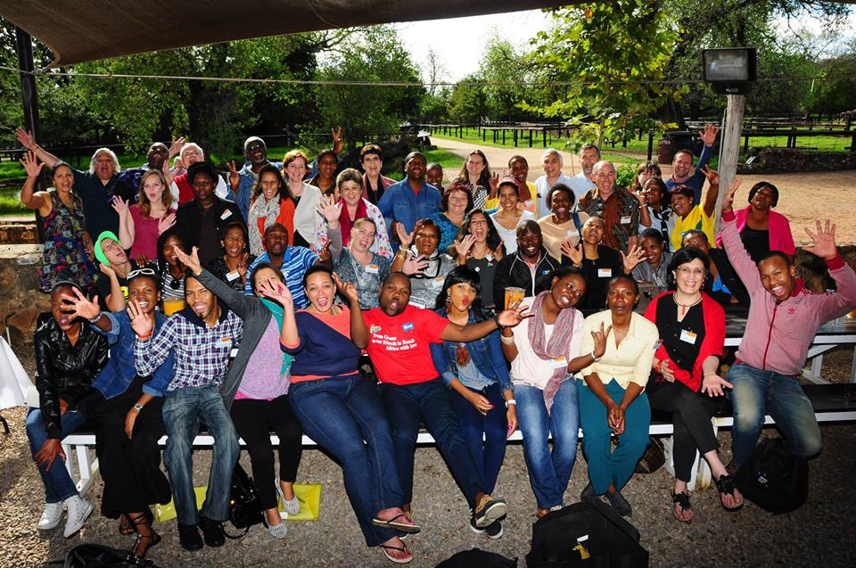

Our Mission
AFS South Africa provides lifelong intercultural opportunities in local and global communities, helping people develop the necessary values, skills and the knowledge and respect needed for a more just peaceful world.
Values and Attributes
AFS enables people to act responsible, global citizen working for Peace and understanding in a diverse world. It acknowledges that peace is a dynamic concept threatened by justice, Inequity and intolerance AFS activities are based on our core values of dignity, respects for difference, harmony, sensitive and tolerance.
Brief History
AFS’s foundations lie in a volunteer-based ambulance corps formed in World War II. When the conflict ended in 1945, AFS’s volunteers, convinced of the need to hasten the post-war healing process, vowed to work towards changing the world’s focus from hostility to friendship.
They decided to do that by exposing young people to cultures other than their own: intercultural learning was a means of developing the knowledge skills, understanding and bonds necessary to create a more just and peaceful world.
In 1947 the former AFS ambulance drivers took a giant step when they pioneered high school exchanges between two of the former combatants, the US and Germany.
Since then more than 325 000 AFS students, families and volunteers have built a global community of shared experiences, close personal bonds and lifetime friendships. Each year, a global AFS network now provides intercultural learning experiences directly to over 12 000 people who participate in AFS programmes and, indirectly, to many more whose lives are touched by our programmes.

AFS code of practice
AFS volunteers shall individually and collectively:
- Respect all people through intercultural understanding and valuing diversity.
- Provide high levels of service delivery and care to participants.
- Enhance the integrity of AFS through standards of personal behavior.
- Support and promote their own and other’s volunteering experience.
Code of practice for AFS volunteers
To promote intercultural understanding, quality service and the value of my AFS experience, I will:
- Be interested in and respectful of other cultures.
- Be committed to the AFS missions, aims and objective and promote the organization in a positive way.
- Abide by:
  - AFS internationally accepted operating values.
  - AFSRSA policies and procedures.
- Seek and carry out roles/tasks within AFS appropriated to my interests, skills and experience and undertake ongoing training.
- Provide high quality customer service to AFS participants by being:
  - Supportive of participant’s welfare and safety.
  - Compliant with AFS health and safety policies and practices.
- Behave with integrity and carry out task/duties in a responsible and ethical manner, maintaining confidentiality.
- Communicate constructively and appropriately with other AFS personnel.
- Value my AFS participation by:
  - Attending AFS events as required.
  - Participating constructively in decision making.
- Be a team-player and respect other AFS volunteers.

Code of practice for AFS RSA
To promote intercultural understanding, quality service and the volunteering experience, AFS South Africa will:
- Be respectful of and inclusive of all cultures.
- Ensure volunteers have a clear understanding of the AFS mission, core values, vision and global education.
- Offer volunteers roles and tasks appropriate to their skills and experience.
- Ensure that volunteers know what is expected of them by providing:
  - Job description.
  - Orientation and training.
  - Policy and procedure manuals.
  - Support feedback and review.
- Implement procedures to safe guard volunteer’s safety and well-being.
- Establish grievance procedures and offer counseling if required.
- Encourage volunteers to participate as valued team/chapter members by:
  - Providing access to relevant decision making processes.
  - Acknowledging and celebrating the contributions made by AFS volunteers.

