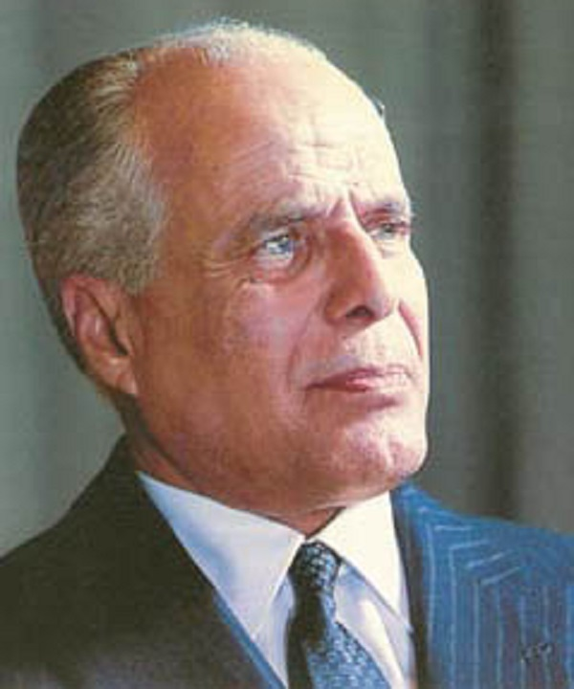
Habib Bourguiba

Habib Bourguiba (3 August 1903 – 6 April 2000)
The first president of the first republic of Tunisia. He is considered as the father of modern Tunisia. After completing a law degree in France during the 1920s, Bourguiba returned to Tunisia and became involved in politics and fighting colonial repression. He founded a political party and a paper and started publishing articles very critical of the French colonial administration of Tunisia. For over 25 years of nationalist struggle, he was imprisoned and exiled several times until he negotiated self-rule for Tunisia in 1954. Two years later, Tunisia becomes an independent country and in 1957 a new modern constitution declaring the country as a republic was voted. Bourguiba was the first president of the first Republic of Tunisia.
Despite turning into an autocratic ruler and a despot during the last years of his regime, Bourguiba was a charismatic leader and enjoyed tremendous popularity among Tunisians. He had a modern vision for Tunisian society and worked tirelessly to implement it. To do that, he focused his efforts on education and women’s liberation. The reforms put in place and the laws enacted were revolutionary for their time and profoundly transformed Tunisian society. Bourguiba and his government made education in Tunisia compulsory and free and especially opened it to girls. A revolutionary set of family laws were voted, giving women equal rights and equal opportunities and an aggressive but efficient family planning and health programme reached all segments of the female population. In a very short time, Tunisia was transformed from a backward poor country to a thriving modernised state. Bourguiba was an instinctive and tireless communicator. He enjoyed traveling all over the country to popularize his modern vision and energize the population.
Famous Quotes:
- "When a house is on fire, the neighbours' duty is to put it out"
- "I hate colonialism, not the French."

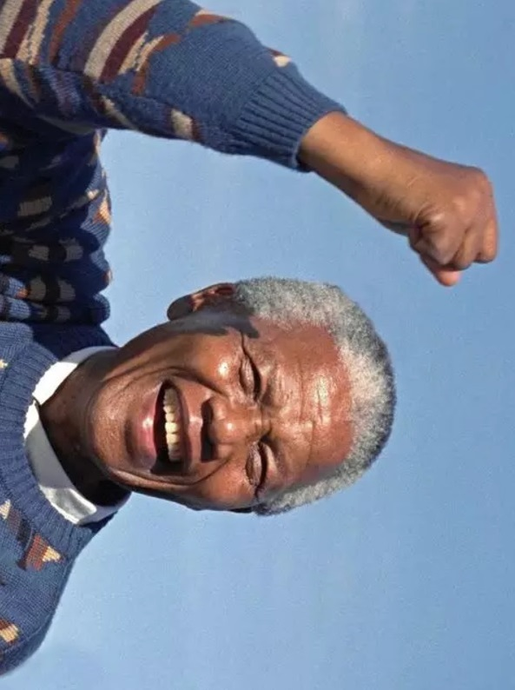
Nelson Mandela

Nelson Rolihlahla Mandela (18 July 1918 – 5 December 2013)
Nelson Mandela was a South African anti-apartheid revolutionary, politician, and philanthropist, who served as President of South Africa from 1994 to 1999. He was the country's first black head of state and the first elected in a fully representative democratic election. His government focused on dismantling the legacy of apartheid by tackling institutionalised racism and fostering racial reconciliation. Ideologically an African nationalist and socialist, he served as President of the African National Congress (ANC) party from 1991 to 1997.
A Xhosa, Mandela was born in Mvezo to the Thembu royal family. He studied law at the University of Fort Hare and the University of the Witwatersrand before working as a lawyer in Johannesburg. There he became involved in anti-colonial and African nationalist politics, joining the ANC in 1943 and co-founding its Youth League in 1944. After the National Party's white-only government established apartheid—a system of racial segregation that privileged whites—he and the ANC committed themselves to its overthrow. Mandela was appointed President of the ANC's Transvaal branch, rising to prominence for his involvement in the 1952 Defiance Campaign and the 1955 Congress of the People. He was repeatedly arrested for seditious activities and was unsuccessfully prosecuted in the 1956 Treason Trial. Influenced by Marxism, he secretly joined the banned South African Communist Party (SACP). Although initially committed to non-violent protest, in association with the SACP he co-founded the militant Umkhonto we Sizwe in 1961 and led a sabotage campaign against the government. In 1962, he was arrested for conspiring to overthrow the state and sentenced to life imprisonment in the Rivonia Trial.
Mandela served 27 years in prison, initially on Robben Island, and later in Pollsmoor Prison and Victor Verster Prison. Amid growing domestic and international pressure, and with fears of a racial civil war, President F. W. de Klerk released him in 1990. Mandela and de Klerk negotiated an end to apartheid and organised the 1994 multiracial general election in which Mandela led the ANC to victory and became President. Leading a broad coalition government which promulgated a new constitution, Mandela emphasised reconciliation between the country's racial groups and created the Truth and Reconciliation Commission to investigate past human rights abuses. Economically, Mandela's administration retained its predecessor's liberal framework despite his own socialist beliefs, also introducing measures to encourage land reform, combat poverty, and expand healthcare services. Internationally, he acted as mediator in the Pan Am Flight 103 bombing trial and served as Secretary-General of the Non-Aligned Movement from 1998 to 1999. He declined a second presidential term and left office in 1999 becoming an elder statesman and focused on combating poverty and HIV/AIDS through his charitable Foundation.
Although critics on the right denounced him as a communist terrorist and those on the radical left deemed him too eager to negotiate and reconcile with apartheid's supporters, he gained international acclaim for his activism. Widely regarded as an icon of democracy and social justice, he received more than 250 honours—including the Nobel Peace Prize. He is held in deep respect within South Africa, where he is often referred to by his Xhosa clan name, Madiba, and described as the "Father of the Nation".
Famous Quotes:
- “What counts in life is not the mere fact that we have lived. It is what difference we have made to the lives of others that will determine the significance of the life we lead.”
- “No one is born hating another person because of the colour of his skin, or his background, or his religion. People must learn to hate, and if they can learn to hate, they can be taught to love, for love comes more naturally to the human heart than its opposite.”
- “Education is the most powerful weapon which you can use to change the world.”
- “As long as poverty, injustice and gross inequality persist in our world, none of us can truly rest.”
- “For to be free is not merely to cast off one's chains, but to live in a way that respects and enhances the freedom of others.”
- “There is nothing like returning to a place that remains unchanged to find the ways in which you yourself have altered.”

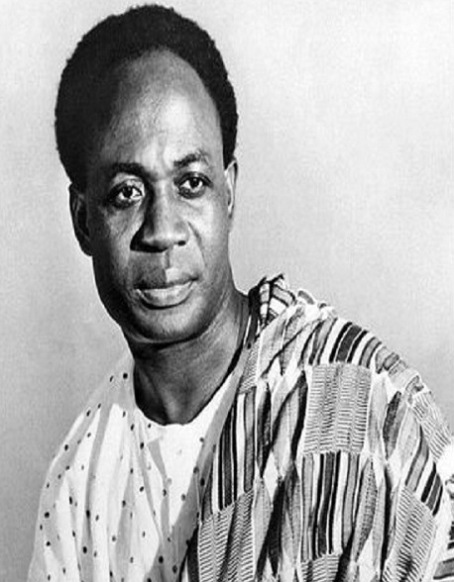
Osagyefo Dr. Kwame Nkrumah

Kwame Nkrumah (18 September 1909 – 27 April 1972)
Kwame Nkrumah was a Ghanaian nationalist leader who led the Gold Coast's independence from Britain and presided over its emergence as the new nation of Ghana. He was the first Prime minister and President of Ghana, having led it to independence from the Britain in 1957. He is an influential advocate of pan-Africanism; Nkrumah was a founding member of the Organization of African Unity and winner of the Lenin peace Prize in 1962.
Increasingly drawn to politics, Nkrumah decided to pursue further studies in the United States. He entered Lincoln University in Pennsylvania in 1935 and, after graduating in 1939, obtained master’s degrees from Lincoln and from the University of Pennsylvania. He studied the literature of socialism, notably Karl Marx and Vladimir Lenin, and of nationalism, especially Marcus Garvey, the black American black leader of the 1920s. Eventually, Nkrumah came to describe himself as a “nondenominational Christian and a Marxist socialist.” He also immersed himself in political work, reorganizing and becoming president of the African Students’ Organization of the United States and Canada. He left the United States in May 1945 and went to England, where he co-organised the 5th Pan-African Congress in Manchester.
After twelve years abroad pursuing higher education, developing his political philosophy, and organising with other diasporic pan-Africanists, Nkrumah returned to Gold Coast to begin his political career as an advocate of national independence. He formed the Convention People’s Party, which achieved rapid success through its unprecedented appeal to the common voter. He became prime minister in 1952 and retained this position when Britain declared Ghana independent in 1957. In 1960, Ghanaians approved a new constitution and elected Nkrumah president.
His administration was both socialist and nationalist. Thus it funded national industrial and energy projects, developed a strong national education system, and promoted a national (and pan-African) culture. Under Nkrumah, Ghana played a leading role in African international relations during the decolonization period. He strongly advocated for a united Africa. He was deposed in 1966 by the National Liberation Council, which, under the supervision of international financial institutions, privatized many of the country's state corporations. Nkrumah lived the rest of his life in Guinea, of which he was named honorary co-president.
Some achievements of Nkrumah
His government tried to establish an egalitarian and socialist society that would provide better life and happiness for all. To this end, the government set up many public corporations and state institutions to cater for the industrial and agricultural needs of the country. While these involved heavy expenditure, they also provided, to a reasonable extent, full employment. It was under Nkrumah that the high number of social services, such as schools, hospitals, housing schemes, and the well-planned network of roads, an international airport in Accra and one of the highest standards of living in Africa were achieved that the average Ghanaian could be proud of.
Nkrumah suppressed sectionalism and tribalism in Ghana and brought a sense of national unity among Ghanaians. He infused the spirit of oneness and pride into Ghanaians. An example of how he achieved this was creating Ghana’s first youth boarding school exchange programme by making it compulsory at the senior high school level to move from your region to another region to study - this is ongoing today. Internationally, Nkrumah relentlessly pursued his idea of Pan-Africanism and emphasised the need for African Unity. This greatly contributed to the formation of the OAU in 1963.
Famous Quotes:
- “It is clear that we must find an African solution to our problems, and that this can only be found in African unity. Divided we are weak; united, Africa could become one of the greatest forces for good in the world.”
- “I am not African because I was born in Africa but because Africa was born in me.”
- “Those who would judge us merely by the heights we have achieved would do well to remember the depths from which we started.”
- “Action without thought is empty. Thought without action is blind.”
- “Africa is a paradox, which illustrates and highlights neo-colonialism. Her earth is rich, yet the products that come from above and below the soil continue to enrich, not Africans predominantly, but groups and individuals who operate to Africa’s impoverishment.”
- “The forces that unite us are intrinsic and greater than the superimposed influences that keep us apart.”

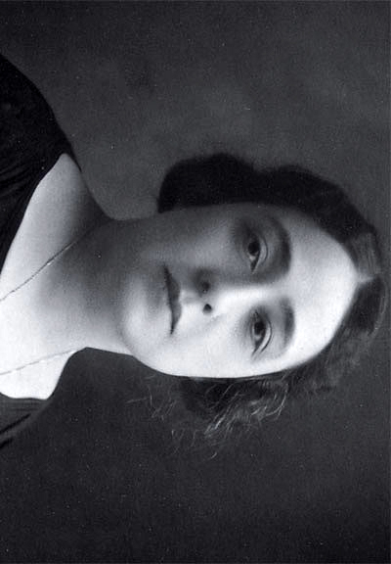
Huda Shaarawi

Huda Shaarawi (1879—1947)
Huda Shaarawi was an Egyptian feminist who influenced not only women in Egypt but throughout the Arab world.
Shaarawi was born into a prosperous family and grew up in the harem system, in which women were confined to secluded apartments within the home and wore face veils when going outside. She received an elite education at home, with the primary language of instruction being French, but also memorised the Qurʾān in Arabic.
Shaarawi had a hand in many “firsts” for women in Egyptian society. In 1908, she founded the first philanthropic society run by Egyptian women, where they offered services for poor women and children. She believed that having women run such projects would challenge the view that women are created for men’s pleasure and in need of protection. In 1910, she opened a school for girls focused on academics, rather than teaching practical skills like midwifery which was common at the time.
She led the first women's street demonstration, the first women's social service organization, and published the first feminist magazine.
In 1923 she founded the Egyptian Feminist Union, which sought woman’s suffrage, reforms to personal status laws, and increased educational opportunities for girls and women. In March of that year she performed the act of protest for which she is best remembered: while returning home from a conference of the International Women Suffrage Alliance in Rome, she removed her face veil in a Cairo train station, causing a commotion. Ten years later, very few women remained veiled in Egypt.
Famous Quote:
- “Men have singled out women of outstanding merit and put them on a pedestal to avoid recognising the capabilities of all women.”

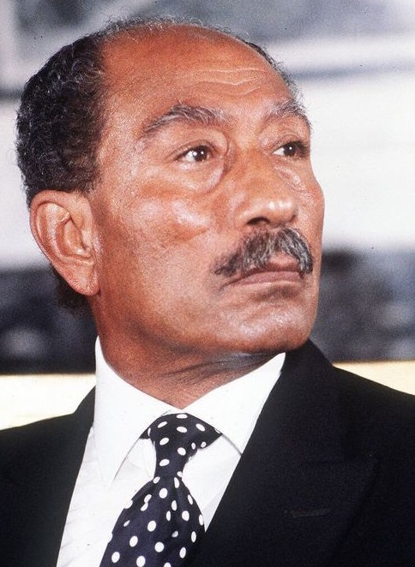
Anwar el-Sadat

Anwar el-Sadat (25 December 1918 – 6 October 1981)
Anwar el-Sadat was the third President of Egypt, serving from 15 October 1970 until his assassination by fundamentalist army officers on 6 October 1981.
In his eleven years as president, he changed Egypt's trajectory, re-instituting a multi-party system, and launching the ‘open’ economic policy. As President, he led Egypt in the 6th of October war in 1973 (also known as Yom Kippur war) to regain Egypt's Sinai Peninsula, which Israel had occupied since the Six-Day War of 1967, making him a hero in Egypt and, for a time, the wider Arab World.
Egypt had been in exhausting conflict and war with Israel since 1948. Convinced that peace with Israel would reap an enormous "peace dividend," Sadat initiated his most important diplomatic ploy. In a speech to the Egyptian parliament in 1977, Sadat affirmed his desire to go anywhere to negotiate a peace with the Israelis. Even, he affirmed, he would go to the Israeli parliament to speak for peace. The Israelis responded with an invitation to do just that and Sadat's speech to the Israeli Knesset initiated a new momentum for peace that would eventually culminate in the 1978 Camp David Accords and a final peace treaty with Israel in 1979 that is still valid to date.
For his bold and courageous efforts, Sadat won the Nobel Prize for Peace.
The country's Muslim Brotherhood, and Arab States felt Sadat had abandoned efforts to ensure a Palestinian state and Arab Unity but he boldly moved on believing more in Peace. The peace treaty was also one of the primary factors that led to his assassination in 1981.
Famous Quotes:
- “There is no happiness for people at the expense of other people.”
- “Peace is much more precious than a piece of land... let there be no more wars.”

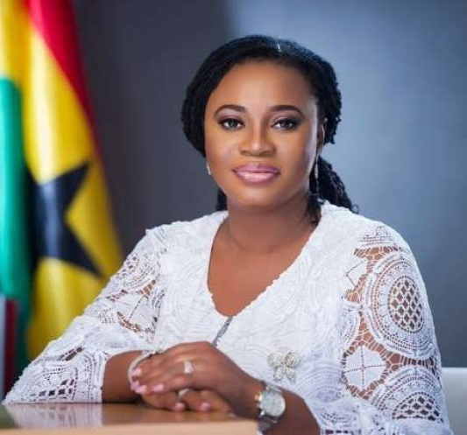
Charlotte Kesson-Smith Osei

Charlotte Kesson-Smith Osei (born 1 February 1969)
Charlotte Osei is the current chairperson of the Electoral Commission of Ghana. She became the first female to serve in this office since the independence of Ghana. Before her appointment she was the chairperson of the National Commission for Civic Education.
Osei had her secondary education at the Ghana National College in Cape Coast. She proceeded to the University of Ghana where she obtained her LLB in 1992 and Ghana School of Law where she obtained and called to the bar in 1994. She also holds Master of Business Leadership (MBL) from the University of South Africa, Pretoria (2006), Master of Laws (LLM), from Queen’s University, Kingston, Ontario. From 2002 until 2005, Osei worked as General Counsel for Unibank Ghana, and then from 2005 until 2011 as founder and lead counsel for business lawyers, Prime Attorneys. She was chairperson of the National Commission for Civic Education from 2011 until 2015. In 2015 she was appointed chairperson of the Electoral Commission of Ghana and she presided as the Returning Officer for Ghana's 2016 Presidential and Parliamentary elections.
Though she constantly kept a low profile, she was always interested in creating a lot of visibility for the National Commission for Civic Education (NCCE), providing education for Ghanaians on their civic rights and responsibilities, voting and knowledge of Ghana’s Constitution in order to strengthen Ghana’s democracy.
Some achievements of Osei
Osei is the First Female Electoral Commissioner of Ghana, she took over from Dr Kwadjo Afari-Gyan, who himself served the commission for close to 22 years.
Osei was honoured with the United States Department of State’s Women of Courage Award for 2017. The United States Ambassador to Ghana, Robert P. Jackson praised Charlotte Osei for her bravery before, during and after the 2016 general elections. She has brought a lot of landmark achievements to the NCCE, including the introduction of a lot more activities such as Citizenship Week, Dialogue Series, Democracy Lectures and the launch of a website where the commission informs the public about its activities.
Prior to being made the Chairperson of the NCCE, she was the founder and lead counsel of Prime Attorneys, a leading law firm in Accra, and had earlier served as a senior legal officer for the GCB Bank Ltd and company secretary/legal advisor for Unibank Ghana Limited.
She has many publications to her name, some being “Reclaiming Ourselves” “Re-examining the Status of Ghanaian Women Under Customary Law.” “Property Rights of Widows in Ghana- An Assessment of the Intestate Succession Law, PNDCL 111”.
Famous Quotes:
- “I owe my courage to the resilient women of Ghana, who are working daily to overcome male chauvinism and patriarchy in all its forms from the micro to the macro level of our society.”
- “I am inspired daily by their refusal to accept the status quo, and to dare to make a difference.”

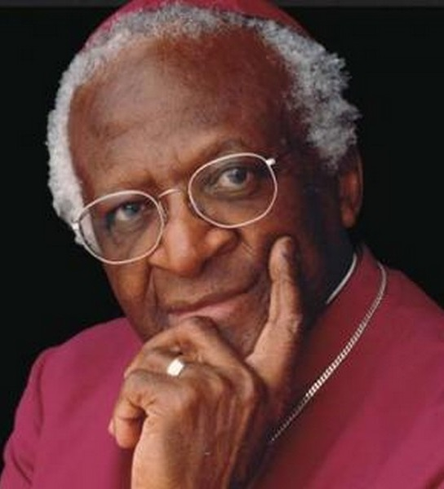
Desmond Tutu

Desmond Tutu (born 7 October 1931)
Desmond Mpilo Tutu is a South African social rights activist and retired Anglican bishop who rose to worldwide fame during the 1980s as an opponent of apartheid. He was the first black Archbishop of Cape Town and bishop of the Church of the Province of Southern Africa (now the Anglican Church of Southern Africa).
Although Tutu wanted to become a doctor, his family could not afford the training, and he followed his father's footsteps into teaching. Tutu studied at the Pretoria Bantu Normal College from 1951 to 1953, and went on to teach at Johannesburg Bantu High School and at Munsienville High School in Mogale City. However, he resigned following the passage of the Bantu Education Act, in protest at the poor educational prospects for black South Africans. He continued his studies, this time in theology, at St Peter's Theological College in Rosettenville, Johannesburg, and in December 1961 was ordained as an Anglican priest following in the footsteps of his mentor and fellow activist, Trevor Huddleston.
In 1976, the protests in Soweto, also known as the Soweto riots, against the government's use of Afrikaans as the compulsory language of instruction in black schools became an uprising against apartheid. From then on Tutu supported an economic boycott of his country. He vigorously opposed the "constructive engagement" policy of the Reagan administration in the United States, which advocated "friendly persuasion". Tutu pressed the advantage and organised peaceful marches which brought 30,000 people onto the streets of Cape Town.
Tutu was Bishop of Lesotho from 1976 until 1978, when he became Secretary-General of the South African Council of Churches. From this position, he was able to continue his work against apartheid with agreement from nearly all churches. Through his writings and lectures at home and abroad, Tutu consistently advocated reconciliation between all parties involved in apartheid. Tutu's opposition to apartheid was vigorous and unequivocal, and he was outspoken both in South Africa and abroad. He often compared apartheid to Nazism; as a result the government twice revoked his passport, and he was jailed briefly in 1980 after a protest march. It was thought by many that Tutu's increasing international reputation and his rigorous advocacy of non-violence protected him from harsher penalties.
When a new constitution was proposed for South Africa in 1983 to defend against the anti-apartheid movement, Tutu helped form the National Forum Committee to fight the constitutional changes.
In 1990, Tutu and the ex-Vice-Chancellor of the University of the Western Cape Professor Jakes Gerwel founded the Desmond Tutu Educational Trust. The Trust – established to fund developmental programmes in tertiary education – provides capacity building at 17 historically disadvantaged institutions.
Tutu's work as a mediator to prevent all-out racial war was evident at the funeral of South African Communist Party leader Chris Hani in 1993. Tutu spurred a crowd of 120,000 to repeat after him the chants, over and over: "We will be free!", "All of us!", "Black and white together!"
Since the demise of apartheid in South Africa, Tutu has campaigned to fight HIV/AIDS, tuberculosis, poverty, racism, sexism, homophobia, and transphobia.
He received the Nobel Peace Prize in 1984; the Albert Schweitzer Prize for Humanitarianism in 1986; the Pacem in Terris Award in 1987; the Sydney Peace Prize in 1999; the Gandhi Peace Prize in 2007; and the Presidential Medal of Freedom in 2009.
Famous Quotes:
- “Do your little bit of good where you are; it's those little bits of good put together that overwhelm the world.”
- “My humanity is bound up in yours, for we can only be human together.”
- “Exclusion is never the way forward on our shared paths to freedom and justice.”
- “Ubuntu is very difficult to render into a Western language. It speaks of the very essence of being human... you are generous, you are hospitable, you are friendly and caring and compassionate. You share what you have. It is to say, 'My humanity is inextricably bound up in yours.' We belong in a bundle of life.”

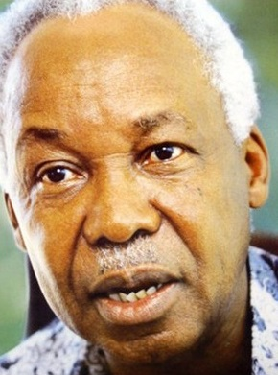
Julius Nyerere

Julius Kambarage Nyerere (13 April 1922 – 14 October 1999)
Julius Nyerere was a Tanzanian anti-colonial activist, politician, and political theorist. He governed Tanganyika as its Prime Minister from 1961 to 1963 and then as its President from 1963 to 1964, after which he led its successor state, Tanzania, as its President from 1964 until 1985. He was a founding member of the Tanganyika African National Union (TANU) party and later a member of the Chama Cha Mapinduzi party. Ideologically an African nationalist and African socialist, he promoted a political philosophy known as Ujamaa.
Born in Butiama, then in the British colony of Tanganyika, Nyerere was the son of a Zanaki chief. After completing his schooling in Tanganyika, he studied at Makerere College in Uganda and then Edinburgh University in Britain. Nyerere was known by the Swahili honorific Mwalimu or 'teacher', his profession prior to politics. He was also referred to as Baba wa Taifa (Father of the Nation). In 1954, he helped form the Tanganyika African National Union, which was instrumental in obtaining independence for Tanganyika.
In March 1955, Nyerere spoke before the UN Trusteeship Council for the first time, saying "with your help and with the help of the [British] Administering Authority we would be governing ourselves long before twenty to twenty-five years." This seemed highly ambitious to everyone at the time. Nyerere's activities attracted the attention of the Colonial authorities and he was forced to make a choice between his political activities and his teaching. He was reported as saying that he was a "schoolmaster by choice and a politician by accident". He resigned from teaching and travelled throughout the country speaking to common people and tribal chiefs, trying to garner support for movement towards independence. He also spoke on behalf of TANU to the Trusteeship Council and Fourth Committee of the United Nations in New York. His oratory skills and integrity helped Nyerere achieve TANU's goal for an independent country without war or bloodshed.
In 1964, Nyerere was instrumental in the union between the islands of Zanzibar and the mainland Tanganyika to form Tanzania with himself as president of the unified country. This was precipitated by the Zanzibar revolution on 12 January 1964 which toppled the Sultan of Zanzibar Jamshid bin Abdullah. The coup leader, a stonemason from Lira, Uganda, named John Okello, had intended Zanzibar to join Kenya. Nyerere, unnerved by a failed mutiny of the Tanganyika Rifles a few days later, ensured that Okello was barred from returning to Zanzibar after a visit to the mainland. In his absence the President of Zanzibar, Abeid Karume, negotiated with Nyerere on Zanzibar's behalf to enter into a union with Tanganyika to form the new country of Tanzania.
After the Presidency, Nyerere remained the Chairman of Chama Cha Mapinduzi (CCM) until 1990 when Ali Hassan Mwinyi took over. Nyerere remained vocal about the extent of corruption and corrupt officials during the Mwinyi administration. However, he raised no objections when the CCM abandoned its monopoly of power in 1992. He also served as Chairman of the independent International South Commission (1987–1990), and Chairman of the South Centre in the Geneva & Dar es Salaam Offices (1990–1999).
In one of his famous speeches during the CCM general assembly, Nyerere said in Swahili "Ninang'atuka", meaning that he was pulling out of politics for good. He kept to his word that Tanzania would be a democratic country. He moved back to his childhood home village of Butiama in northern Tanzania. During his retirement, he continued to travel the world meeting various heads of government as an advocate for poor countries and especially the South Centre institution. One of his last high-profile actions was as the chief mediator in the Burundi conflict in 1996.
Famous Quotes:
- “You cannot develop people. You must allow people to develop themselves.”
- “Education is not a way to escape poverty; it is a way of fighting it.”
- “In Tanzania, it was more than one hundred tribal units which lost their freedom; it was one nation that regained it.”

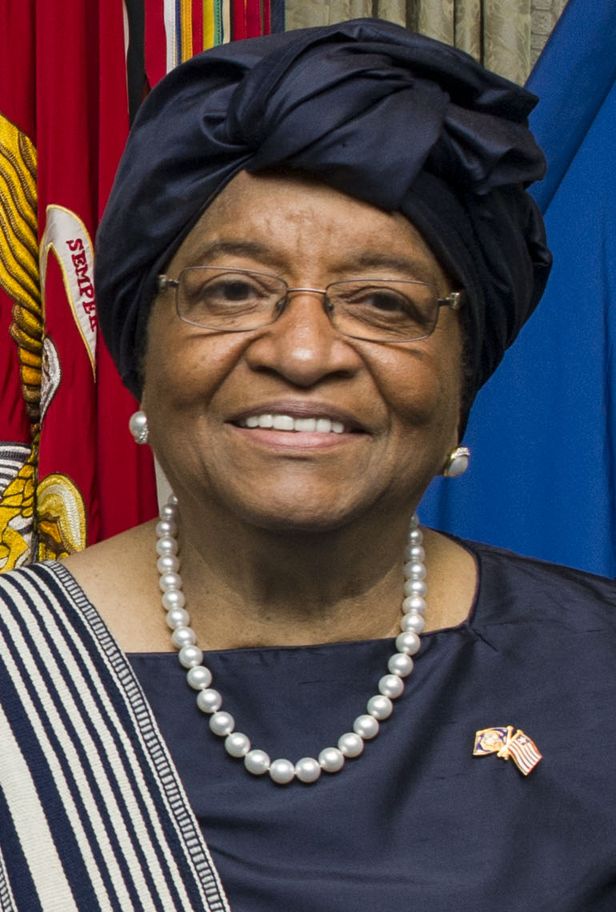
Ellen Johnson Sirleaf
Ellen Johnson Sirleaf (born 29 October 1938)
Ellen Johnson Sirleaf is a Liberian politician who serves as the 24th and current President of Liberia since 2006. Sirleaf was the first elected female head of state in Africa.
Sirleaf was born in Monrovia to a Gola father and Kru-German mother. She was educated at the College of West Africa before moving to the United States where she studied at Madison Business College and Harvard University. She returned to Liberia to work in William Tolbert's government as Assistant Minister of Finance from 1973–74 and Minister of Finance from 1979–80. After Samuel Doe seized power in a coup d'état and executed Tolbert, Sirleaf fled to the US. She worked for the World Bank before moving to Nairobi, where she worked for Citibank and then the Equator Bank.
She placed second in the 1997 presidential election won by Charles Taylor. She won the 2005 presidential election and took office on 16 January 2006, and she was re-elected in 2011. In June 2016, she was elected as the Chair of the Economic Community of West African States, making her the first woman to occupy that position since it was formed. Sirleaf was jointly awarded the 2011 Nobel Peace Prize with Leymah Gbowee of Liberia and Tawakkol Karman of Yemen. The women were recognized "for their non-violent struggle for the safety of women and for women's rights to full participation in peace-building work."
Sirleaf was conferred the Indira Gandhi Prize by President of India Pranab Mukherjee on 12 September 2013.
Famous Quotes:
- “The size of your dreams must always exceed your current capacity to achieve them. If your dreams do not scare you, they are not big enough.”
- “Future generations will judge us not by what we say, but what we do.”
- “Ethnicity should enrich us; it should make us a unique people in our diversity and not be used to divide us.”
- “We are here because we share a fundamental belief: that poverty, illiteracy, disease and inequality do not belong in the twenty-first century. We share a common purpose: to eradicate these ills for the benefit of all. And we share a common tool to achieve this: the Millennium Development Goals.”

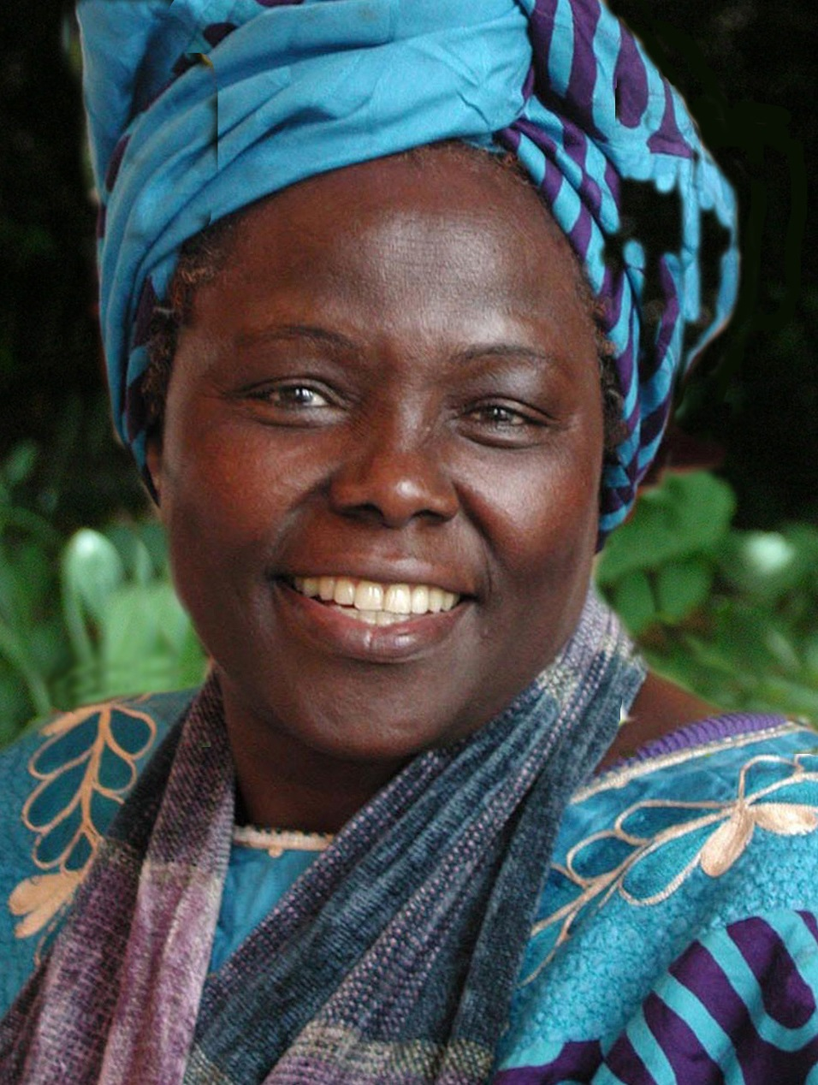
Wangari Maathai

Wangari Maathai (1 April 1940 – 25 September 2011)
Wangari Maathai was an internationally renowned Kenyan environmental political activist and Nobel laureate. She was educated in the United States at Mount St. Scholastica (Benedictine College) and the University of Pittsburgh, as well as the University of Nairobi in Kenya.
In 1977, Maathai founded the Green Belt Movement, an environmental non-governmental organization focused on the planting of trees, environmental conservation, and women's rights.
The UN held the third global women's conference in Nairobi. During the conference, Maathai arranged seminars and presentations to describe the work the Green Belt Movement was doing in Kenya. She escorted delegates to see nurseries and plant trees. She met Peggy Snyder, the head of UNIFEM, and Helvi Sipilä, the first woman appointed a UN assistant secretary general. The conference helped to expand funding for the Green Belt Movement and led to the movement's establishing itself outside Kenya. In 1986, with funding from UNEP, the movement expanded throughout Africa and led to the foundation of the Pan-African Green Belt Network. Forty-five representatives from fifteen African countries travelled to Kenya over the next three years to learn how to set up similar programmes in their own countries to combat desertification, deforestation, water crises, and rural hunger.
In 1984, she was awarded the Right Livelihood Award, and, in 2004, she became the first African woman to receive the Nobel Peace Prize for "her contribution to sustainable development, democracy and peace".
Maathai was an elected member of Parliament and served as assistant minister for Environment and Natural Resources in the government of President Mwai Kibaki between January 2003 and November 2005. She was an Honorary Councillor of the World Future Council. In 2011, Maathai died of complications from ovarian cancer.
Famous Quotes:
- “When we plant trees, we plant the seeds of peace and seeds of hope.”
- “You cannot enslave a mind that knows itself. That values itself. That understands itself.”
- “It's the little things citizens do. That's what will make the difference. My little thing is planting trees.”
- “No matter who or where we are, or what our capabilities, we are called to do the best we can.”

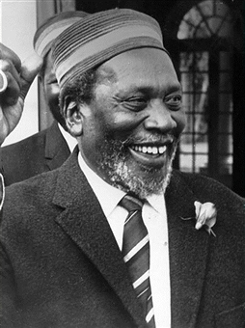
Jomo Kenyatta

Jomo Kenyatta (c. 1897 – 22 August 1978)
Jomo Kenyatta was a Kenyan anti-colonial activist and politician who governed Kenya as its Prime Minister from 1963 to 1964 and then as its first President from 1964 to 1978. He was the country's first black head of government and played a significant role in the transformation of Kenya from a colony of the British Empire into an independent republic. Ideologically an African nationalist and conservative, he led the Kenya African National Union (KANU) party from 1961 until his death.
Kenyatta was born to Kikuyu farmers in Kiambu, British East Africa. Educated at a mission school, he worked in various jobs before becoming politically engaged through the Kikuyu Central Association. In 1929, he travelled to London to lobby for Kikuyu tribal land affairs. During the 1930s he studied at Moscow's Communist University of the Toilers of the East, University College London, and the London School of Economics. In 1938 he published an anthropological study of Kikuyu life before working as a farm labourer in Sussex during the Second World War.
Influenced by his friend George Padmore, he embraced anti-colonialist and Pan-African ideas, co-organising the 1945 Pan-African Congress in Manchester. In 1946, he returned to Kenya and became a school principal. In 1947 he was elected President of the Kenya African Union, through which he lobbied for independence from British colonial rule, attracting both widespread support and the animosity of white settlers. In 1952, he was among the Kapenguria Six arrested and charged with masterminding the anti-colonial Mau Mau Uprising. Although protesting his innocence—a view shared by later historians—he was convicted. He remained imprisoned at Lokitaung until 1959 and then exiled in Lodwar until 1961.
On his release, Kenyatta was appointed President of KANU and led the party to victory in the 1963 general election. Desiring a one-party state, he suppressed much political dissent and prohibited KANU's only rival, the leftist Kenya People's Union, from competing in elections. Powers from Kenya's regions were redistributed to its central government. He promoted reconciliation between the country's indigenous tribal groups and its European minority, although his relations with the Kenyan Indians was strained.
His government pursued capitalist economic policies and the "Africanisation" of the economy, with non-citizens prohibited from controlling key industries. Under Kenyatta, Kenya joined the Organisation of African Unity and the British Commonwealth, espousing a pro-Western and anti-communist foreign policy.
Within Kenya, Kenyatta came to be regarded as the "Father of the Nation", viewed as a father figure by Kikuyu, Kenyans, and Africans more widely. In Kenya, Kenyatta came to be known as Mzee, a term of respect for one's elders. In 1974, Guy Arnold referred to Kenyatta as "one of the outstanding African leaders now living", someone who had become "synonymous with Kenya". He added that Kenyatta had been "one of the shrewdest politicians" on the continent, regarded as "one of the great architects of African nationalist achievement since 1945". In their examination of his writings, Bruce J. Berman and John M. Lonsdale described him as a "pioneer" for being one of the very first Kikuyu to write and publish; "his representational achievement was unique".
Famous Quotes:
- “Our children may learn about heroes of the past. Our task is to make ourselves architects of the future.”
- “Unity cannot be taken for granted.”
- “Where there has been racial hatred, it must be ended. Where there has been tribal animosity, it will be finished. Let us not dwell upon the bitterness of the past. I would rather look to the future, to the good new Kenya, not to the bad old days.”

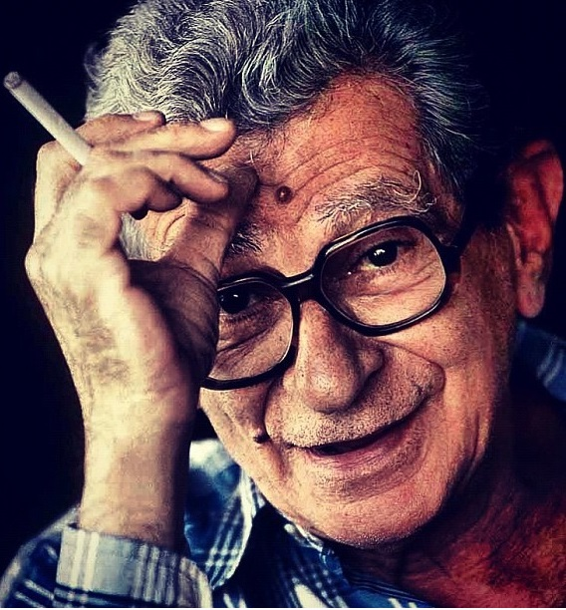
Youssef Chahine

Youssef Chahine (25 January 1926 – 27 July 2008)
Youssef Chahine was born in Alexandria, Egypt, and started studying in a freres' school, he then turned to English College until the High School Certificate. After one year in the University of Alexandria, he moved to the U.S. and spent two years at the Pasadena Play House, taking courses on film and dramatic arts.

He earned the title "the pioneer of social realism" in Egyptian cinema. Chahine's 1957 Bab el Hadid (Cairo Station, 1957) starred the director himself as a crippled newspaper seller at Cairo's main railway station. Although social realism was his trademark during a 55-year career, Chahine went through different phases, using a range of styles and genres, while maintaining his distinctive cinematic language throughout. Chahine used historic events to try to shed light on what was happening in the present, while keeping an eye on the censor's reaction. Djamila (Jamila, The Algerian, 1958), for instance, was an exaggerated account of the activities of the Algerian revolutionary Djamila Bouhired, in which the heroine is tortured by the French. Chahine moved to Beirut, but on hearing that Nasser was asking why this "mad artist" was not working in Egypt, he returned home. He then produced several films that mixed the dreams of the individual with bigger historic events.

Chahine's epic El-Nasser Salah el Dine (Saladin, 1963) was a reflection of this. A loose adaptation of one of the battles of the Islamic hero Saladin, it was made in CinemaScope with two battalions and 120 cavalrymen of Nasser's army put at Chahine's disposal. He used a similar theme in Wada’n Bonaparte (Adieu, Bonaparte, 1985). Set in the period of the Napoleonic expedition into Egypt, the film explores the complex relationships between East and West when a homosexual French general falls in love with a local Egyptian. The "well of cultural strength" was his childhood in Alexandria, a city that always resisted the Arabisation, and later the Islamisation, of Egypt.

His film debut was Baba Amin (1950): one year later, with Son of the Nile (1951) He was first invited to the Cannes Film festival.
In 1970, he was awarded a Golden Tanit at the Carthage Festival. With Le moineau (1973), he directed the first Egypt-Algeria co-production. He won a Silver Bear in Berlin for Iskanderija... lih? (1979). In 1997 Chahine received a special award from the Cannes film festival. In his later years he became more outspoken in criticising oppression in the Arab world as well as America's foreign policy which he believed contradicted her contribution to the world. He had been much influenced by Hollywood as a young film-maker. "All we see is Spider-Men and musclemen," he said in 2005. "America has become violent like the new movies."
In 1997, 46 years and 5 invitations later, he was again selected Hors Competition in Cannes with Destiny.

Famous Quotes:
- “I am young. I am only 81 years old. I hope I can keep working for another 10 years. Old age is to let oneself become old.”
- “’Suffering was given to man so that he might transform it into song', said Homer. Since then, what has the artist done but the same work of transformation, again and again?”
- "Thoughts have wings. No one can prevent them from flying." (from Destiny)

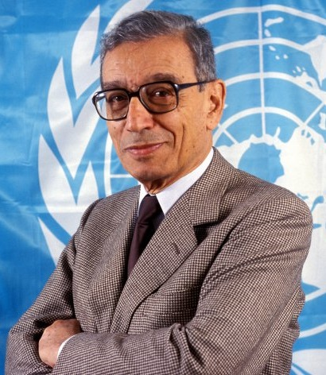
Boutros Boutros-Ghali

Boutros Boutros-Ghali (14 November 1922 – 16 February 2016)
Boutros Boutros-Ghali was respected around the world for his distinguished career as a lawyer, scholar, and international diplomat. As secretary-general of the United Nations, he sought to re-establish the leadership role of that international organization in world affairs.

He was born into one of the Egyptian Coptic-Christian community's most influential and wealthiest families. He left university life and academics in October 1977 and was appointed Egyptian minister of state for foreign affairs, he accompanied President Anwar Sadat (1918–1981). During the 1980s he was involved in Egyptian politics as a leading member of the National Democratic Party and as a delegate to the Egyptian parliament. In May 1991 President Hosni Mubarak promoted him to deputy prime minister for international affairs.

Upon taking office as UN Secretary-General in January 1992, Boutros Boutros-Ghali became the world's leading spokesman for, and practitioner of, internationalism (the goal of which is for countries to peacefully cooperate to solve problems). Boutros-Ghali used his position at the UN to call all countries and governments to fulfil the original 1945 UN pledge of a global political system. He held up the United Nations and its various agencies as an organisation that could promote international peace and security, economic development, and human rights through international cooperation. But on the immediate and more practical level, much of his energy went toward putting the United Nations' own house in order. The most important of his goals was to broaden the United Nations' role of peacekeeping. His goal was to ensure greater effectiveness by the time of the United Nations' fiftieth anniversary in 1995. Boutros-Ghali remained willing to speak his mind until the end of his term in 1996.

His biggest diplomatic accomplishment pre-dates his time as UN Secretary General. Serving as Egypt's foreign minister under President Anwar el-Sadat, he played a key role in negotiating the Camp David agreement brokered by the US president Jimmy Carter.

A former Egyptian foreign minister, Mr Boutros-Ghali led the world body during one of its most difficult times, with crises in Somalia, Rwanda, the Middle East and the former Yugoslavia. His five years in office were clouded by controversy, especially about perceived UN inaction over the 1994 Rwandan genocide and Angolan civil war of the 1990s.

Famous Quotes:
- “Only stupid people don’t change their minds.”
- “Nobody is interested in the poor countries in Africa or anywhere in the world. They can easily forget Somalia in 24 hours.”
- “I will continue to work for the advancement of freedoms in Egypt and the Arab world until I drop dead.”

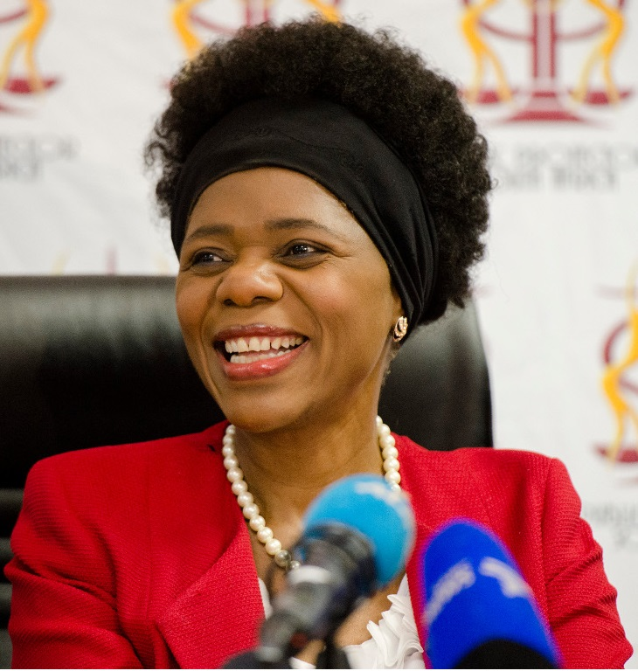
Thuli Madonsela
Thuli Madonsela (born 28 September 1962)
Thuli Madonsela was born in Johannesburg, the daughter of informal traders, and grew up in Soweto. She has always had a strong sense of community since starting her career as a union organiser and teacher in the 1980s. She was a member of the team that drafted the final constitution of South Africa promulgated by President Nelson Mandela in 1996. After Mandela's death, Madonsela said in a tribute to him "We will always admire him for gladly submitting his administration to the scrutiny of checks and balances such as the courts and institutions supporting democracy when its actions came into question." Prior to her appointment as Public Protector, Madonsela served as a full-time member of the South African Law Reform Commission.
Madonsela was appointed Public Protector by President Jacob Zuma for a non-renewable seven-year term commencing 19 October 2009, with unanimous support from the multi-party National Assembly.
In 2012, she investigated "kickbacks" received by Julius Malema in the context of traffic department contracts given to external contractor On-Point Engineering. Madonsela also investigated complaints regarding public spending on Zuma's private homestead in the KwaZulu-Natal town of Nkandla. Her final report on security upgrades to Zuma's homestead titled Secure in Comfort was published on 19 March 2014.
Her report was met with much criticism and opposition from representatives of the ANC. ANC MPs in the justice portfolio committee objected to Madonsela's "views that are political in nature" and committee chairperson Mathole Motshekga suggested that the powers of the Public Protector, which are governed by the country's constitution, be reviewed. Opposition parties approached the Constitutional Court to enforce Madonsela's findings after they were dismissed in Parliament. On 31 March 2016, the Constitutional Court delivered a unanimous judgement stating that the Public Protector's report was binding and Zuma and the National Assembly had failed to uphold the country's constitution.
Thuli Madonsela was named Forbes Africa Person of the Year 2016.

Famous Quotes:
- "I need to listen well so that I hear what is not said."
- “It helps to always remind ourselves that forgiveness is for our own healing and peace, it's not about the offender. Have a peaceful day!”
- “If we commenced each day with the question: How will l improve life in this world today our actions would be purpose driven and impactful.”
- “When you find yourself seeing what's not yet visible to others, don't be discouraged, for such is the burden and gift of leadership.”
- “The job is about protecting the public from improper conduct from whatever quarter it may come from. So stick to that job.”

Saran Kaba Jones

Saran Kaba Jones (born 21 June 1982)
Saran Kaba Jones is a Liberian national who fled her country at the age of 8 with her family in the wake of the devastating civil war which lasted well over a decade. Returning home in 2008 - nearly 20 years later, she came face to face with the harsh economic realities of a post-conflict Liberia. “The long and devastating civil war had left Liberia’s infrastructure in ruins - roads, buildings, health clinics, schools, farms and factories were almost totally destroyed,” she says. “There was no electricity, no running water or sewage system, and an inadequate education system.”
She is not one to whine about inadequacies, but rather the type who finds audacious and creative solutions to them. In order to address the problems of contaminated water, she founded Face Africa, a non-profit organization that provides access to clean and safe drinking water for rural communities in Liberia, using an innovative social enterprise model to fund water projects. Today Face Africa provides clean drinking water to tens of thousands of Liberians and has plans to support programmes around Africa.
She is a Board Member of the UN Women Civil Society Advisory Group West/Centre Africa and a 2015 Recipient of the MTV Africa Music Leadership Award for her work on Ebola Response in Liberia. She is World Economic Forum Young Global Leader and a 2016 TIME Magazine Next Generation Leader.

Famous Quotes:
- “To me, a leader is someone who listens, inspires and empowers. If you can guide others into a direction that leaves them feeling accomplished and empowered, that makes you a leader.”
- “I would like to create a world where clean water is a reality for millions across sub-Saharan Africa because I believe that access to clean and safe water is a basic human right.”

